**Spring CORE**

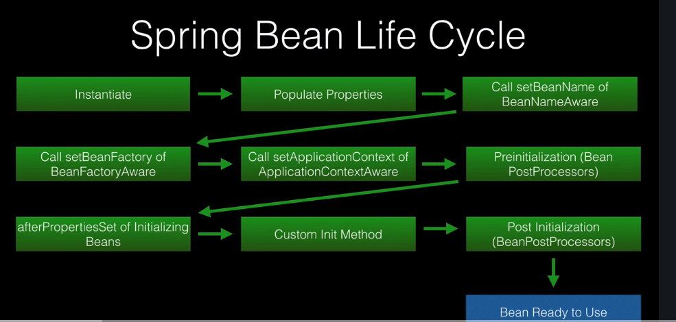

Spring provides two interfaces that can be implemented for callback events:

1. InitializingBean.afterPropertiesSet()
2. DisposableBean.destroy()

OR

1. @PostConstruct
2. @PreDestroy

**Aware Interfaces**

* Spring has over 14 Aware Interfaces
* These are used to access the Spring Framework infrastructure
* These are largely used within the framework
* Rarely used by Spring Developers

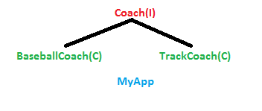

**public interface Coach** {  
   
 **public** String getDailyWorkout();  
   
 }

**public class BaseballCoach** **implements Coach** {   
   
 @Override  
 **public** String getDailyWorkout() {  
 **return "Spend 30 minutes on batting practice"**;  
 }  
  
}

**public class TrackCoach** **implements Coach** {  
  
 @Override  
 **public** String getDailyWorkout() {  
 **return "Run a hard 5k"**;  
 }  
  
}

**public class** MyApp {  
  
 **public static void** main(String[] args) {  
  
 *// create the object  
 // Coach theCoach = new BaseballCoach();* Coach theCoach = **new** TrackCoach();  
   
 *// use the object* System.***out***.println(theCoach.getDailyWorkout());   
 }  
  
}

Coach theCoach = **new** TrackCoach(); // Still we are creating the Object, we want to eliminate this.

We need to have support for the configuration. Spring provides the Object factory that will give the object based on the configuration file.

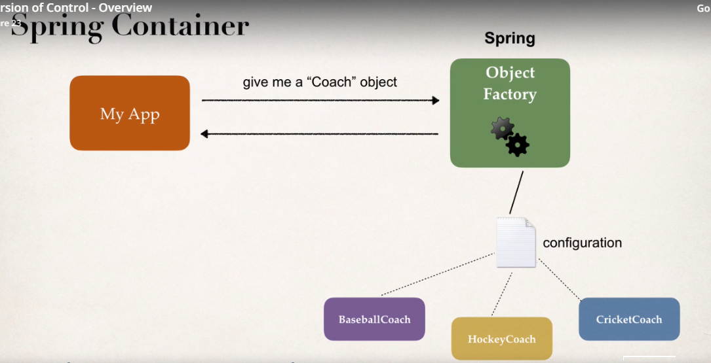

MyApp wants Coach object, So ObjectFactory will give the object by reading it from the configuration file.

**Spring container:**

1. Create and manage Objects(Inversion of control).
2. Inject Object’s dependencies(Dependency Injection).

**Configuring Spring Container:**

1. XML configuration file (legacy)
2. Java Annotations (modern)
3. Java Source code(modern)

**Spring development process:**

1. Configuring your spring beans
2. Create a spring container
3. Retrieve beans from spring container.
4. **Configuring your spring beans**

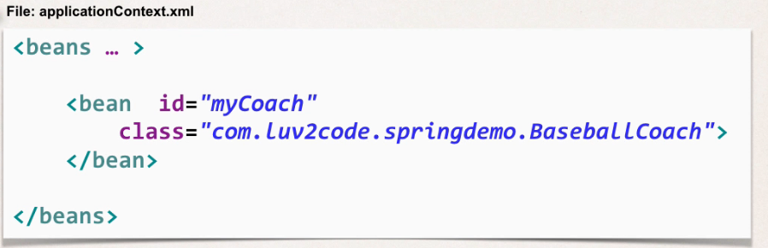

1. **Create a spring container**

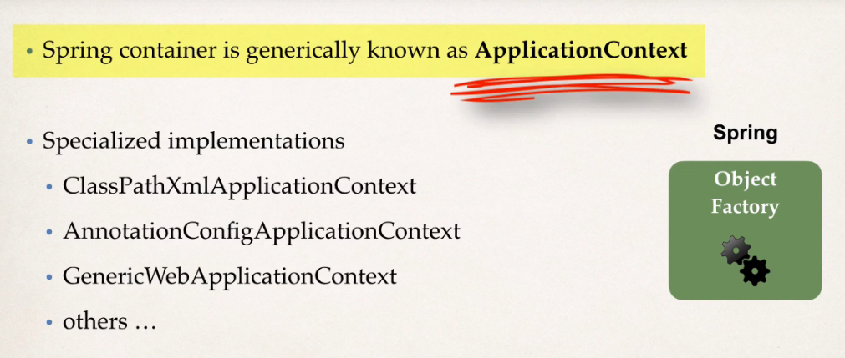

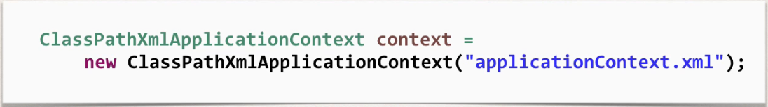

1. **Retrieve beans from spring container.**

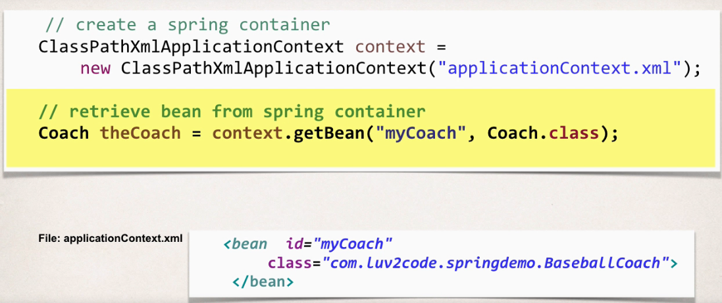

**Question**

**Why do we specify the Coach interface in getBean()?**

**For example:**

Coach theCoach = context.getBean("myCoach", Coach.class);

**Answer**

When we pass the interface to the method, behind the scenes Spring will cast the object for you.

context.getBean("myCoach", Coach.class)

However, there are some slight differences than normal casting.

From the Spring docs:

Behaves the same as getBean(String), but provides a measure of type safety by throwing a BeanNotOfRequiredTypeException if the bean is not of the required type. This means that ClassCastException can't be thrown on casting the result correctly, as can happen with getBean(String).

**Dependency Injection:**

1. Setter Injection
2. Constructor Injection.
3. Constructor Injection:

Suppose BaseballCoach uses FortuneService and is dependent upon it.

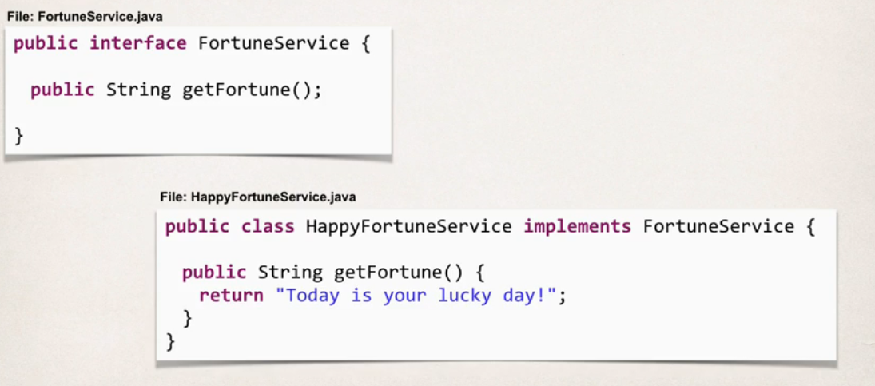

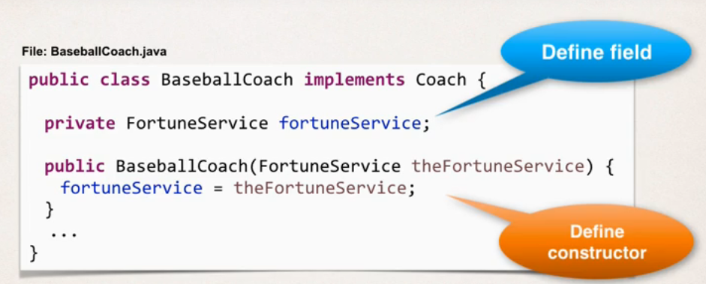

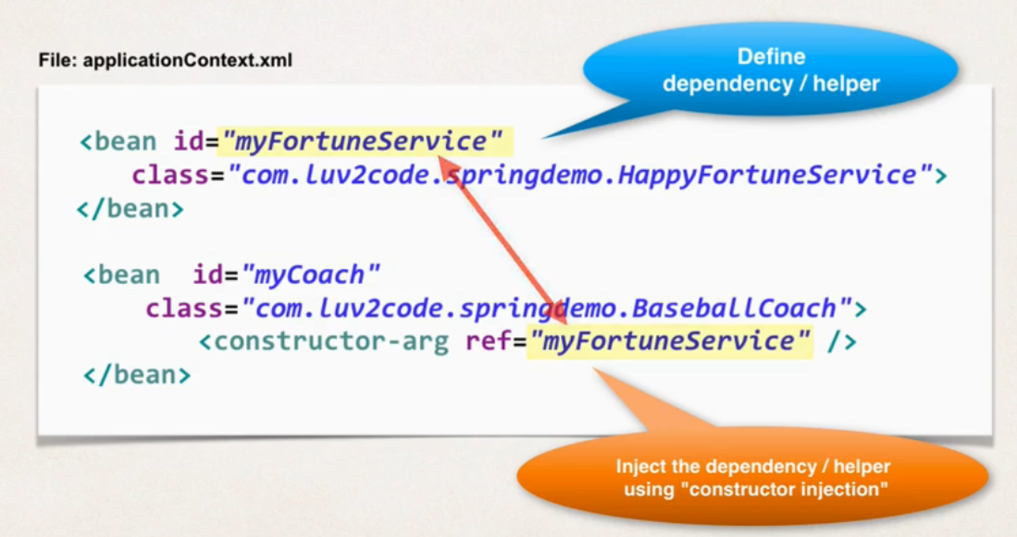

**What is happening Behind the scenes?**

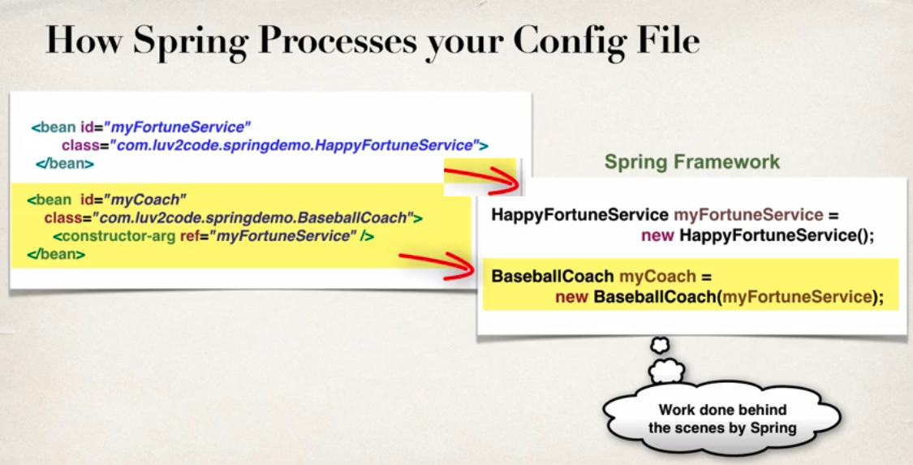

1. **Setter Injection:**

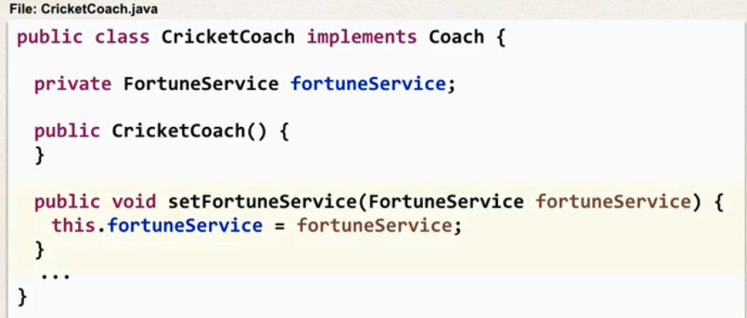

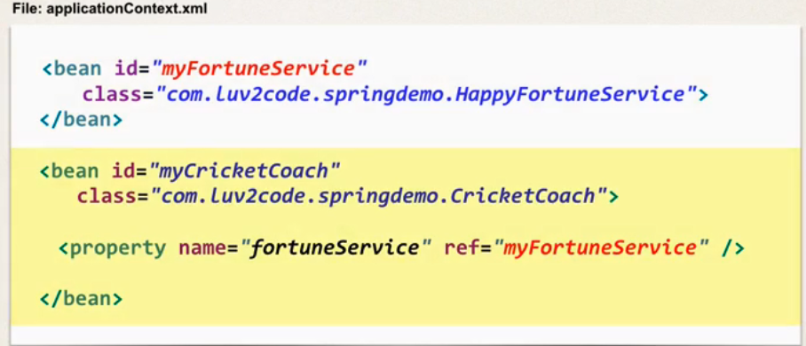

**Read From Property File:**

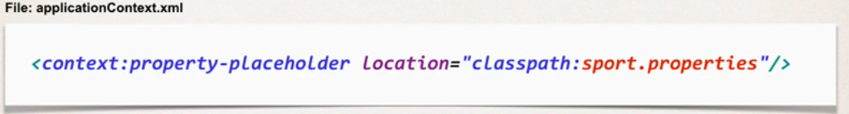

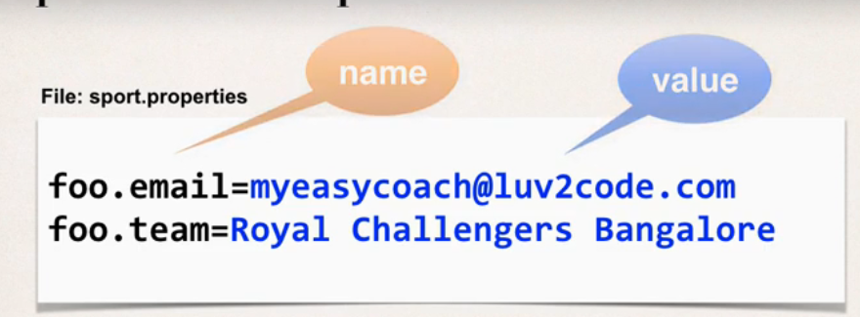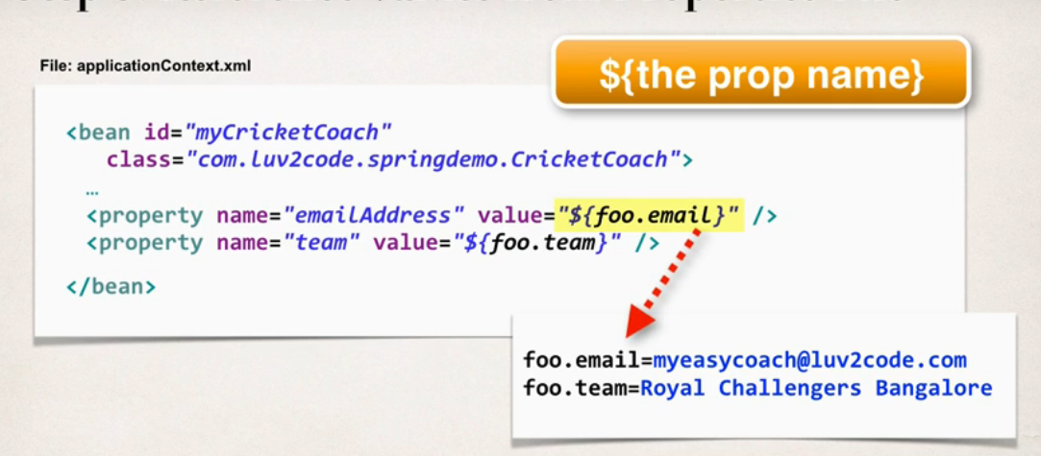

**Bean Scopes:**

1. Scope refers to the lifecycle of the bean.
2. How long does the bean is alive.
3. How many instances are created.
4. How is the bean shared.

Default scope of the spring bean is singleton.

**Bean Life Cycle:**

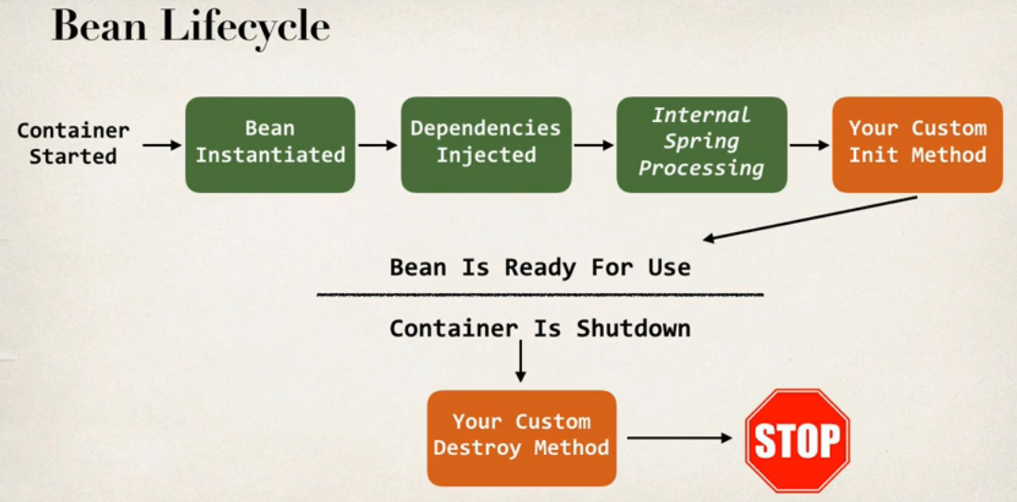

**Bean Life cycle:**

* you can add custom code during bean initialization
* you can add custom code during bean destruction.

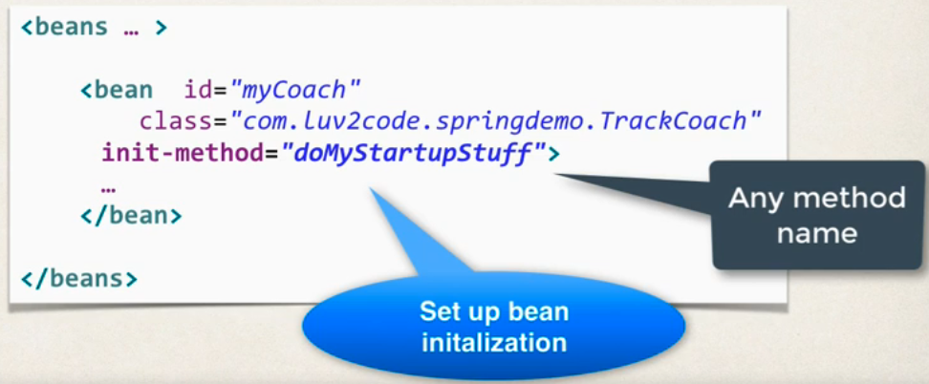

**OR**

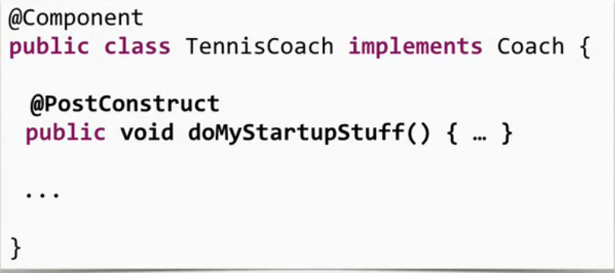

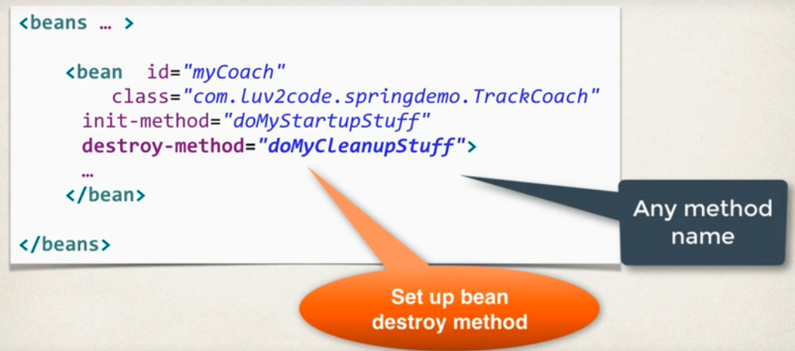

**OR**

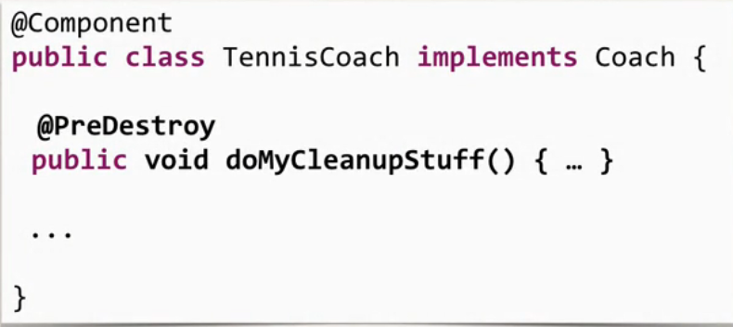

**#NOTE 1**

**Special Note about init and destroy Method Signatures**

When using XML configuration, I want to provide additional details regarding the method signatures of the init-method and destroy-method.

**Access modifier**  
Method can have any access modifier (public, protected, private)

**Return type**  
Method can have any return type. However, "void' is most commonly used. If you give a return type just note that you will not be able to capture the return value. As a result, "void" is commonly used.

**Method name**  
Method can have any method name.

**Arguments**  
Method cannot accept any arguments. The method should be no-arg.

**#NOTE 2**

**For "prototype" scoped beans, Spring does not call the destroy method.  Gasp!**

***In contrast to the other scopes, Spring does not manage the complete lifecycle of a prototype bean****: the container instantiates, configures, and otherwise assembles a prototype object, and hands it to the client, with no further record of that prototype instance.*

*Thus, although initialization lifecycle callback methods are called on all objects regardless of scope,****in the case of prototypes, configured destruction lifecycle callbacks are not called****. The client code must clean up prototype-scoped objects and release expensive resources that the prototype bean(s) are holding.*

This also applies to both XML configuration and Annotation-based configuration.

**Spring Configuration with Annotations:**

1. **Enable component scanning in config file.**

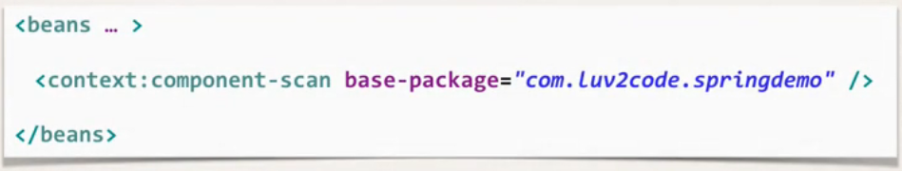

1. **Add @Component/@Controller/@Service/@Repository to java class.**

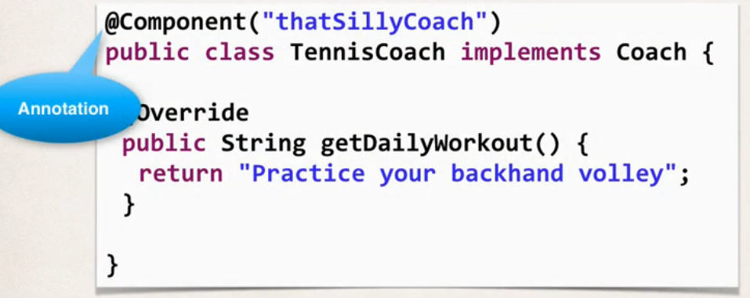

1. **Retrieve Bean from Spring container**

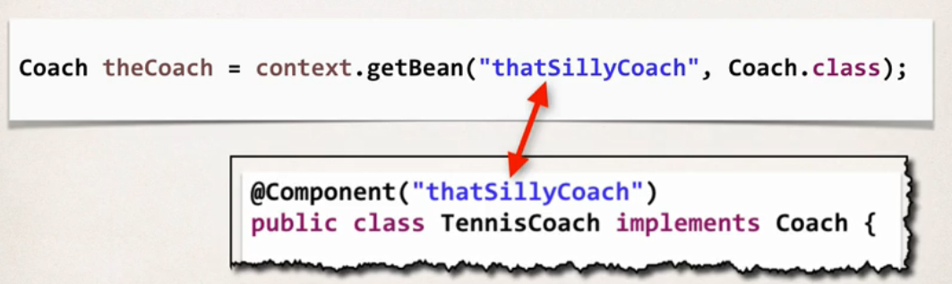

**Question**

I have commented the Autowired annotation. But still it worked. How did it work?

1. //@Autowired
2. public TennisCoach(FortuneService theFortuneService) {
3. System.out.println(" theFortuneService " + theFortuneService);
4. fortuneService = theFortuneService;
5. }

===

**Answer**

This is a new feature of Spring 4.3.

Here is the snippet from the Spring Docs.

**Section 1.9.2: Autowired**

*As of Spring Framework 4.3, an @Autowired annotation on such a constructor is no longer necessary if the target bean only defines one constructor to begin with. However, if several constructors are available, at least one must be annotated to teach the container which one to use.*

Prefer to use the @Autowired annotation because it makes the code more readable. But as mentioned, the @Autowired is not required for this scenario.

---

See link to the docs.

<https://docs.spring.io/spring/docs/current/spring-framework-reference/core.html#beans-autowired-annotation>

**@Autowired:**

1. Can be used with the setter
2. Can be used with the constructors
3. Can be used with Field(uses Reflection behind the scenes)

If FortuneService have many classes that implements it then we use **@Qualifier.**

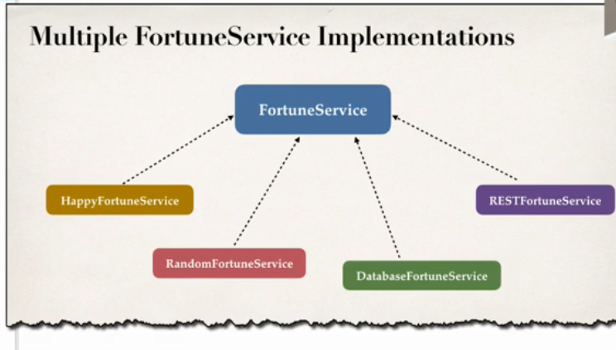

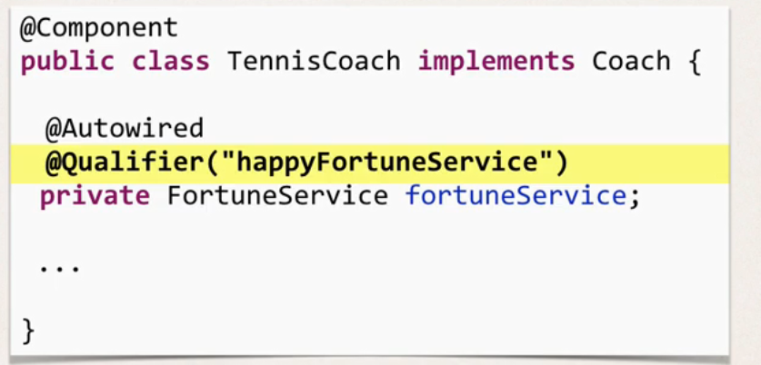

**#NOTE 3**

**Annotations - Default Bean Names ... and the Special Case**

In general, when using Annotations, for the default bean name, Spring uses the following rule.

If the annotation's value doesn't indicate a bean name, an appropriate name will be built based on the short name of the class (with the first letter lower-cased).

For example:

HappyFortuneService --> happyFortuneService

---

However, for the **special case of when BOTH the first and second characters of the class name are upper case**, then the **name is NOT converted**.

For the case of RESTFortuneService

RESTFortuneService --> RESTFortuneService

No conversion since the first two characters are upper case.

Behind the scenes, Spring uses the **Java Beans Introspector** to generate the default bean name. Here's a screenshot of the documentation for the key method.

As always, you can give explicity names to your beans.

@Component("foo")  
public class RESTFortuneService .... {  
      
}

Then you can access it using the name of "foo". Nothing tricky to worry about :-)

**@Qualifier** is a nice feature, but it is tricky when used with Constructors.

The syntax is much different from other examples and not exactly intuitive.

 You have to place the @Qualifier annotation inside of the constructor arguments.

Here's an example from our classroom example. I updated it to make use of constructor injection, with @Autowired and @Qualifier. Make note of the code in bold below:

@Component  
**public class** TennisCoach **implements** Coach {  
 **private** FortuneService **fortuneService**;  
 *// define a default constructor* **public** TennisCoach() {  
 System.***out***.println(**">> TennisCoach: inside default constructor"**);  
 }  
  
 @Autowired  
 **public** TennisCoach(@Qualifier(**"randomFortuneService"**) FortuneService theFortuneService) {  
 System.***out***.println(**">> TennisCoach: inside constructor using @autowired and @qualifier"**);  
  
 **fortuneService** = theFortuneService;  
 }

 **Question:**   **How to inject properties file using Java annotations**

**Answer:**

**1. Create a properties file to hold your properties. It will be a name value pair.**

New text file:  src/sport.properties

1. foo.email=myeasycoach@luv2code.com
2. foo.team=Silly Java Coders

**2. Load the properties file in the XML config file.**

File: applicationContext.xml

Add the following lines:

    <context:property-placeholder location="classpath:sport.properties"/>

This should appear just after the <context:component-scan .../> line

**3. Inject the properties values into your Swim Coach: SwimCoach.java**

1. @Value("${foo.email}")
2. private String email;
4. @Value("${foo.team}")
5. private String team;

**Spring Configuration using Java Code.**

**Three ways**

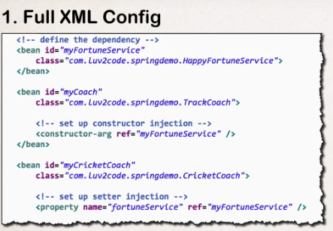

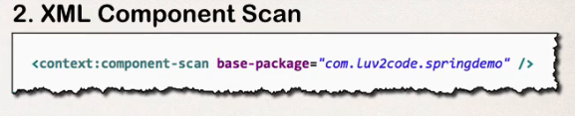

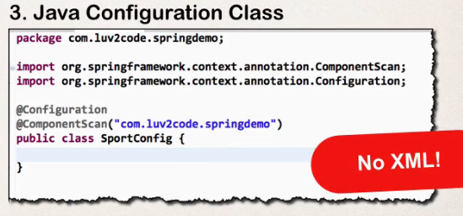

**Example:**

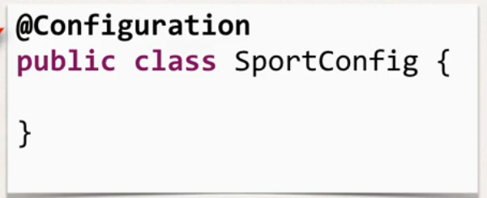

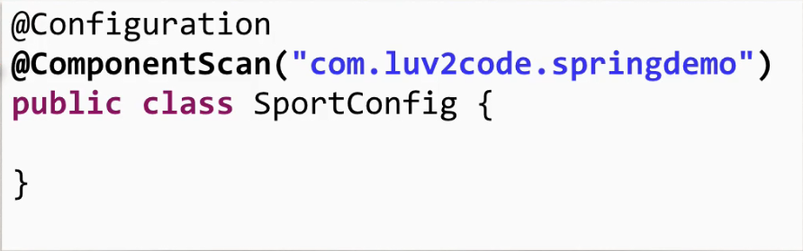

**In the above we have used @ComponentScan, but we can define beans manually. Above will work same as it worked when we used**

**<context:component-scan base-package=”com.*”> in applicationContext.xml.**

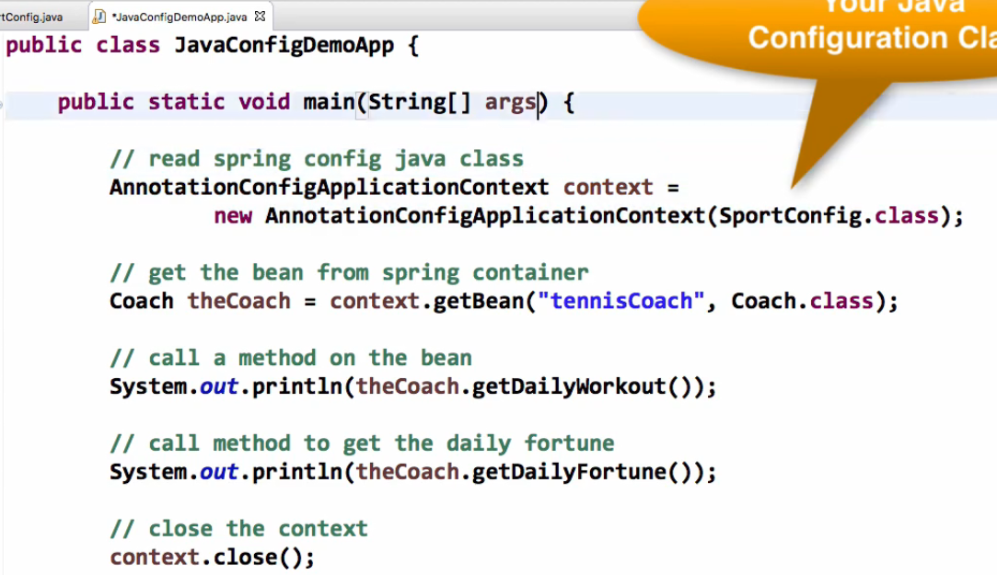

**As you can see above, we have used(NO MORE XML ☺)**

**AnnotationConfigApplicationContext context**

**= new AnnotationConfigApplicationContext(SportConfig.class);**

***Without @ComponentScan***

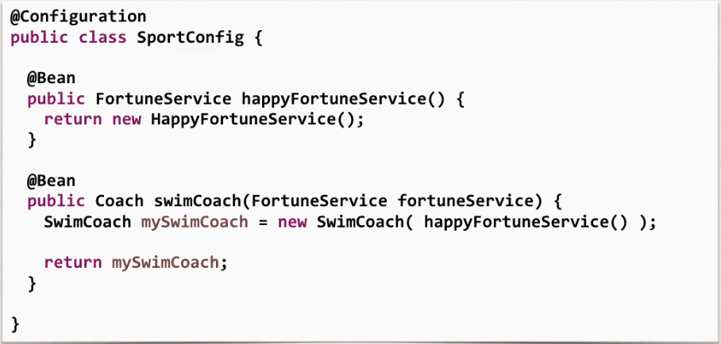

**Here happyFortuneService() is passed in SwimCoach constructoe for the constructor injection.**

**Reading values from Properties File:**

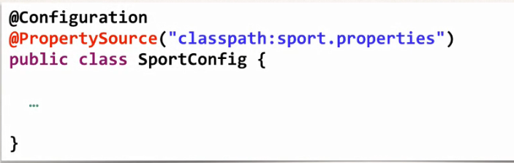

**Question: Problems with Injecting Values - Value not returning from ${foo.email}**

**Question**

**I am running the code for Java Configuration and injecting values from props file. However, I'm getting:**

**${foo.email}  
${foo.team}**

**Instead of the actual property values. How can I resolve this?**

**Answer**

This is an issue with Spring versions.

If you are using Spring 4.2 and lower, you will need to add the code in bold.

**@Configuration  
*// @ComponentScan("com.luv2code.springdemo")*@PropertySource("classpath:sport.properties")**  
**public class** SportConfig {  
  
 *// add support to resolve ${...} properties* **@Bean**  
 **public static** PropertySourcesPlaceholderConfigurer  
 propertySourcesPlaceHolderConfigurer() {  
  
 **return new** PropertySourcesPlaceholderConfigurer();  
 }  
  
 *// define bean for our sad fortune service* **@Bean** **public** FortuneService sadFortuneService() {  
 **return new** SadFortuneService();  
 }  
  
 *// define bean for our swim coach AND inject dependency* **@Bean** **public** Coach swimCoach() {  
 SwimCoach mySwimCoach = **new** SwimCoach(sadFortuneService());  
  
 **return** mySwimCoach;  
 }  
  
}

**In Spring 4.3 and higher, they removed this requirement. As a result, you don't need this code.**

***Spring @Primary***

Suppose you have an interface:

public interface MyService *{* void myImplementation*()*;  
*}*

And this interfaces have Two classses that implements it.

@Service   
public class MyServiceEnglishImpl implements MyService *{* @Override  
 public void myImplementation*() {* System.*out*.println*(*"English"*)*;  
 *}  
}*

@Service  
@Primary  
public class MyServiceGermanImpl implements MyService *{* @Override  
 public void myImplementation*() {* System.*out*.println*(*"German"*)*;  
 *}  
}*

Main class: You will not be able to autowire it as it has two implementation classes

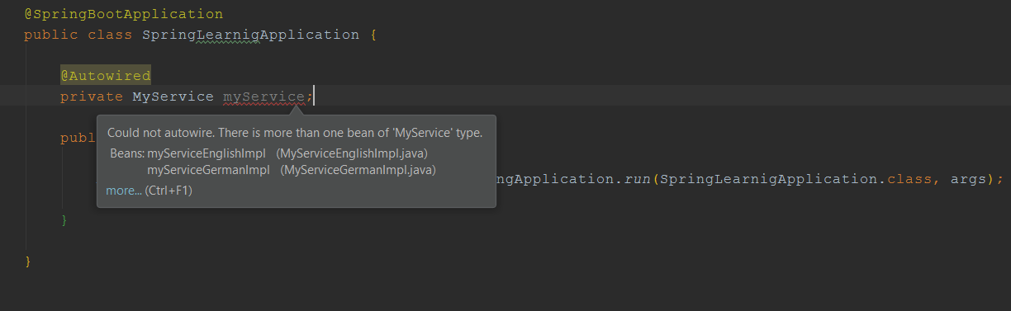

We can solve the above problem by :

1. use only one implementation class per interface
2. Use the name of implementing class as a reference

* @Autowired  
  private MyService **myServiceEnglishImpl**;

Or

* @Autowired  
  private MyService **myServiceGermanImpl**;

1. use primary in any one of that
2. use profiles
3. use profiles with default

So if there are two classes implementing one interface and both are primary, we have to use Profiles. If both are having profiles, we have to give default in one of them or we have to set Profile in application.properties

@Service  
@Primary  
@Profile*({*"en","default"*})*public class MyServiceEnglishImpl implements MyService *{* @Override  
 public void myImplementation*() {* System.*out*.println*(*"English"*)*;  
 *}  
}*